# UI DESIGN

# Design Wireframes

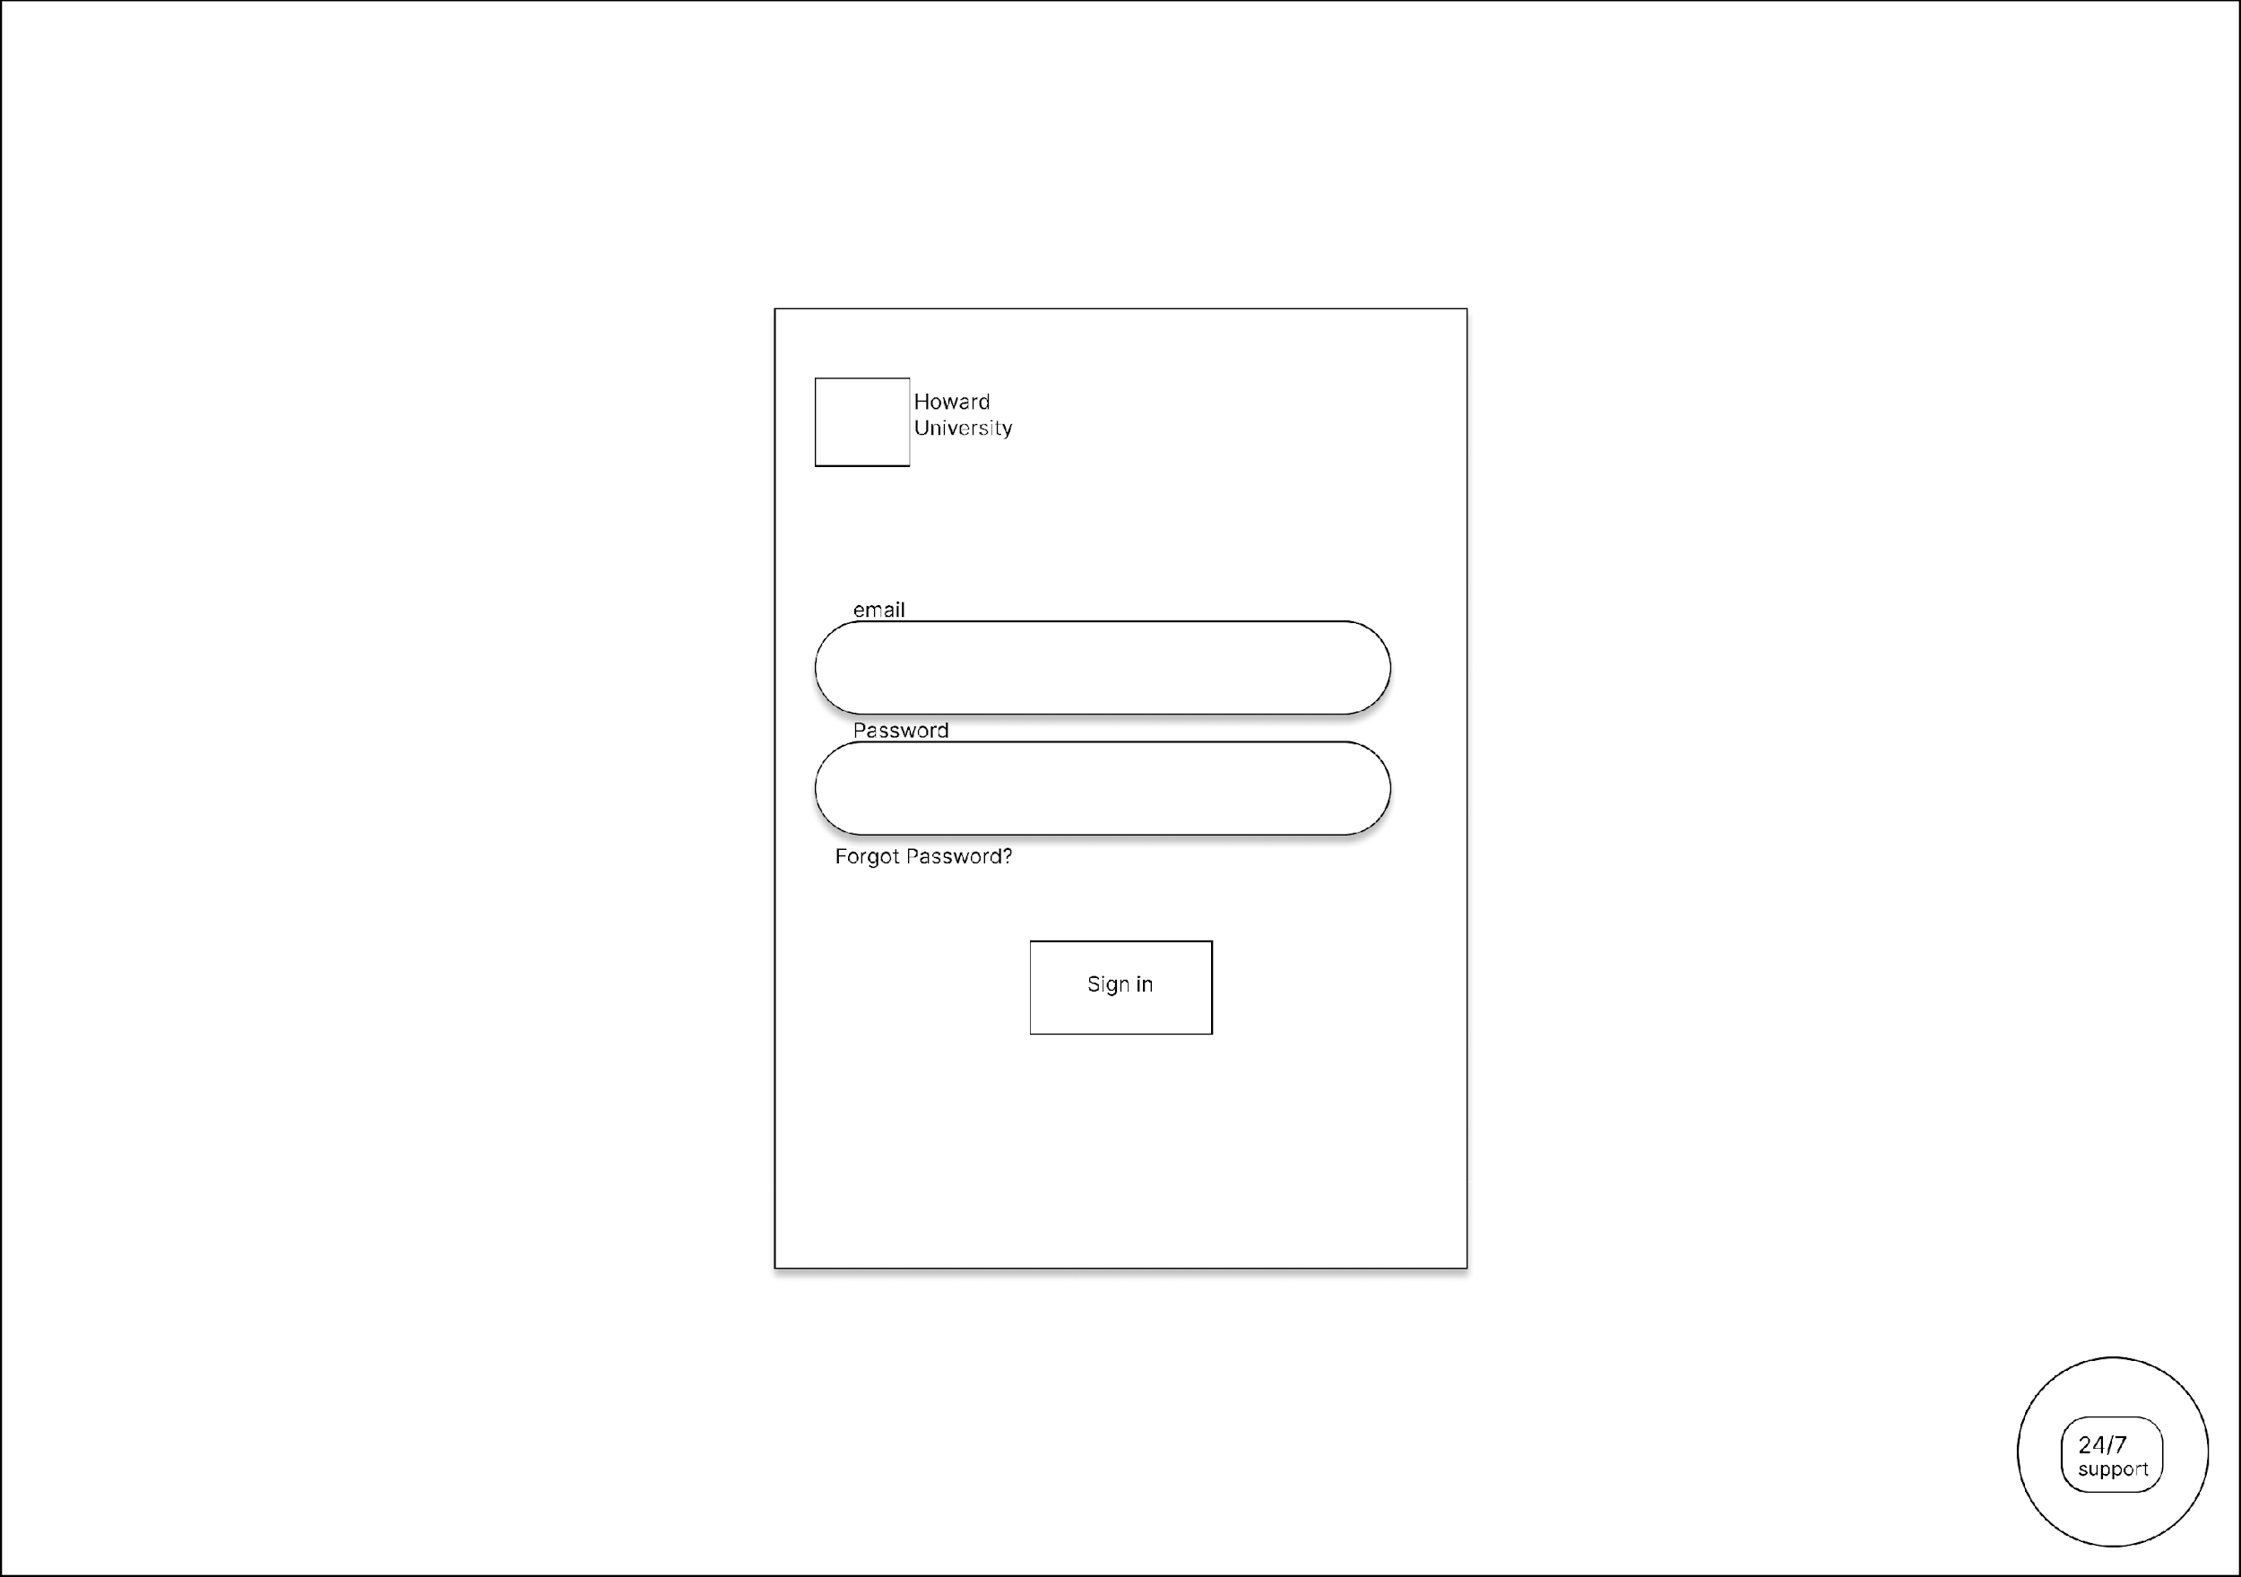

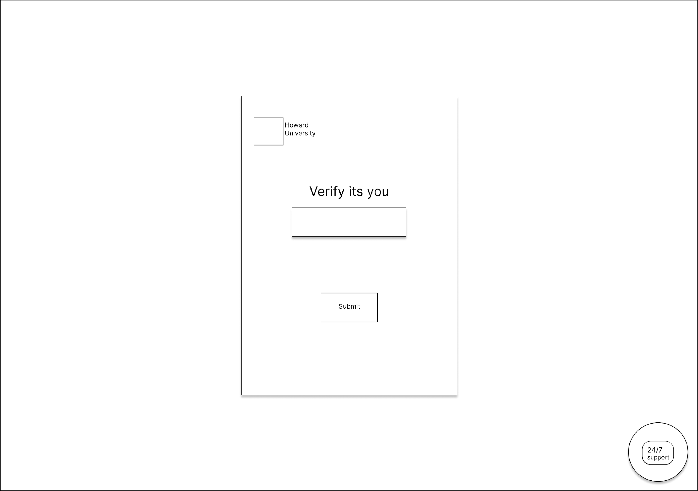

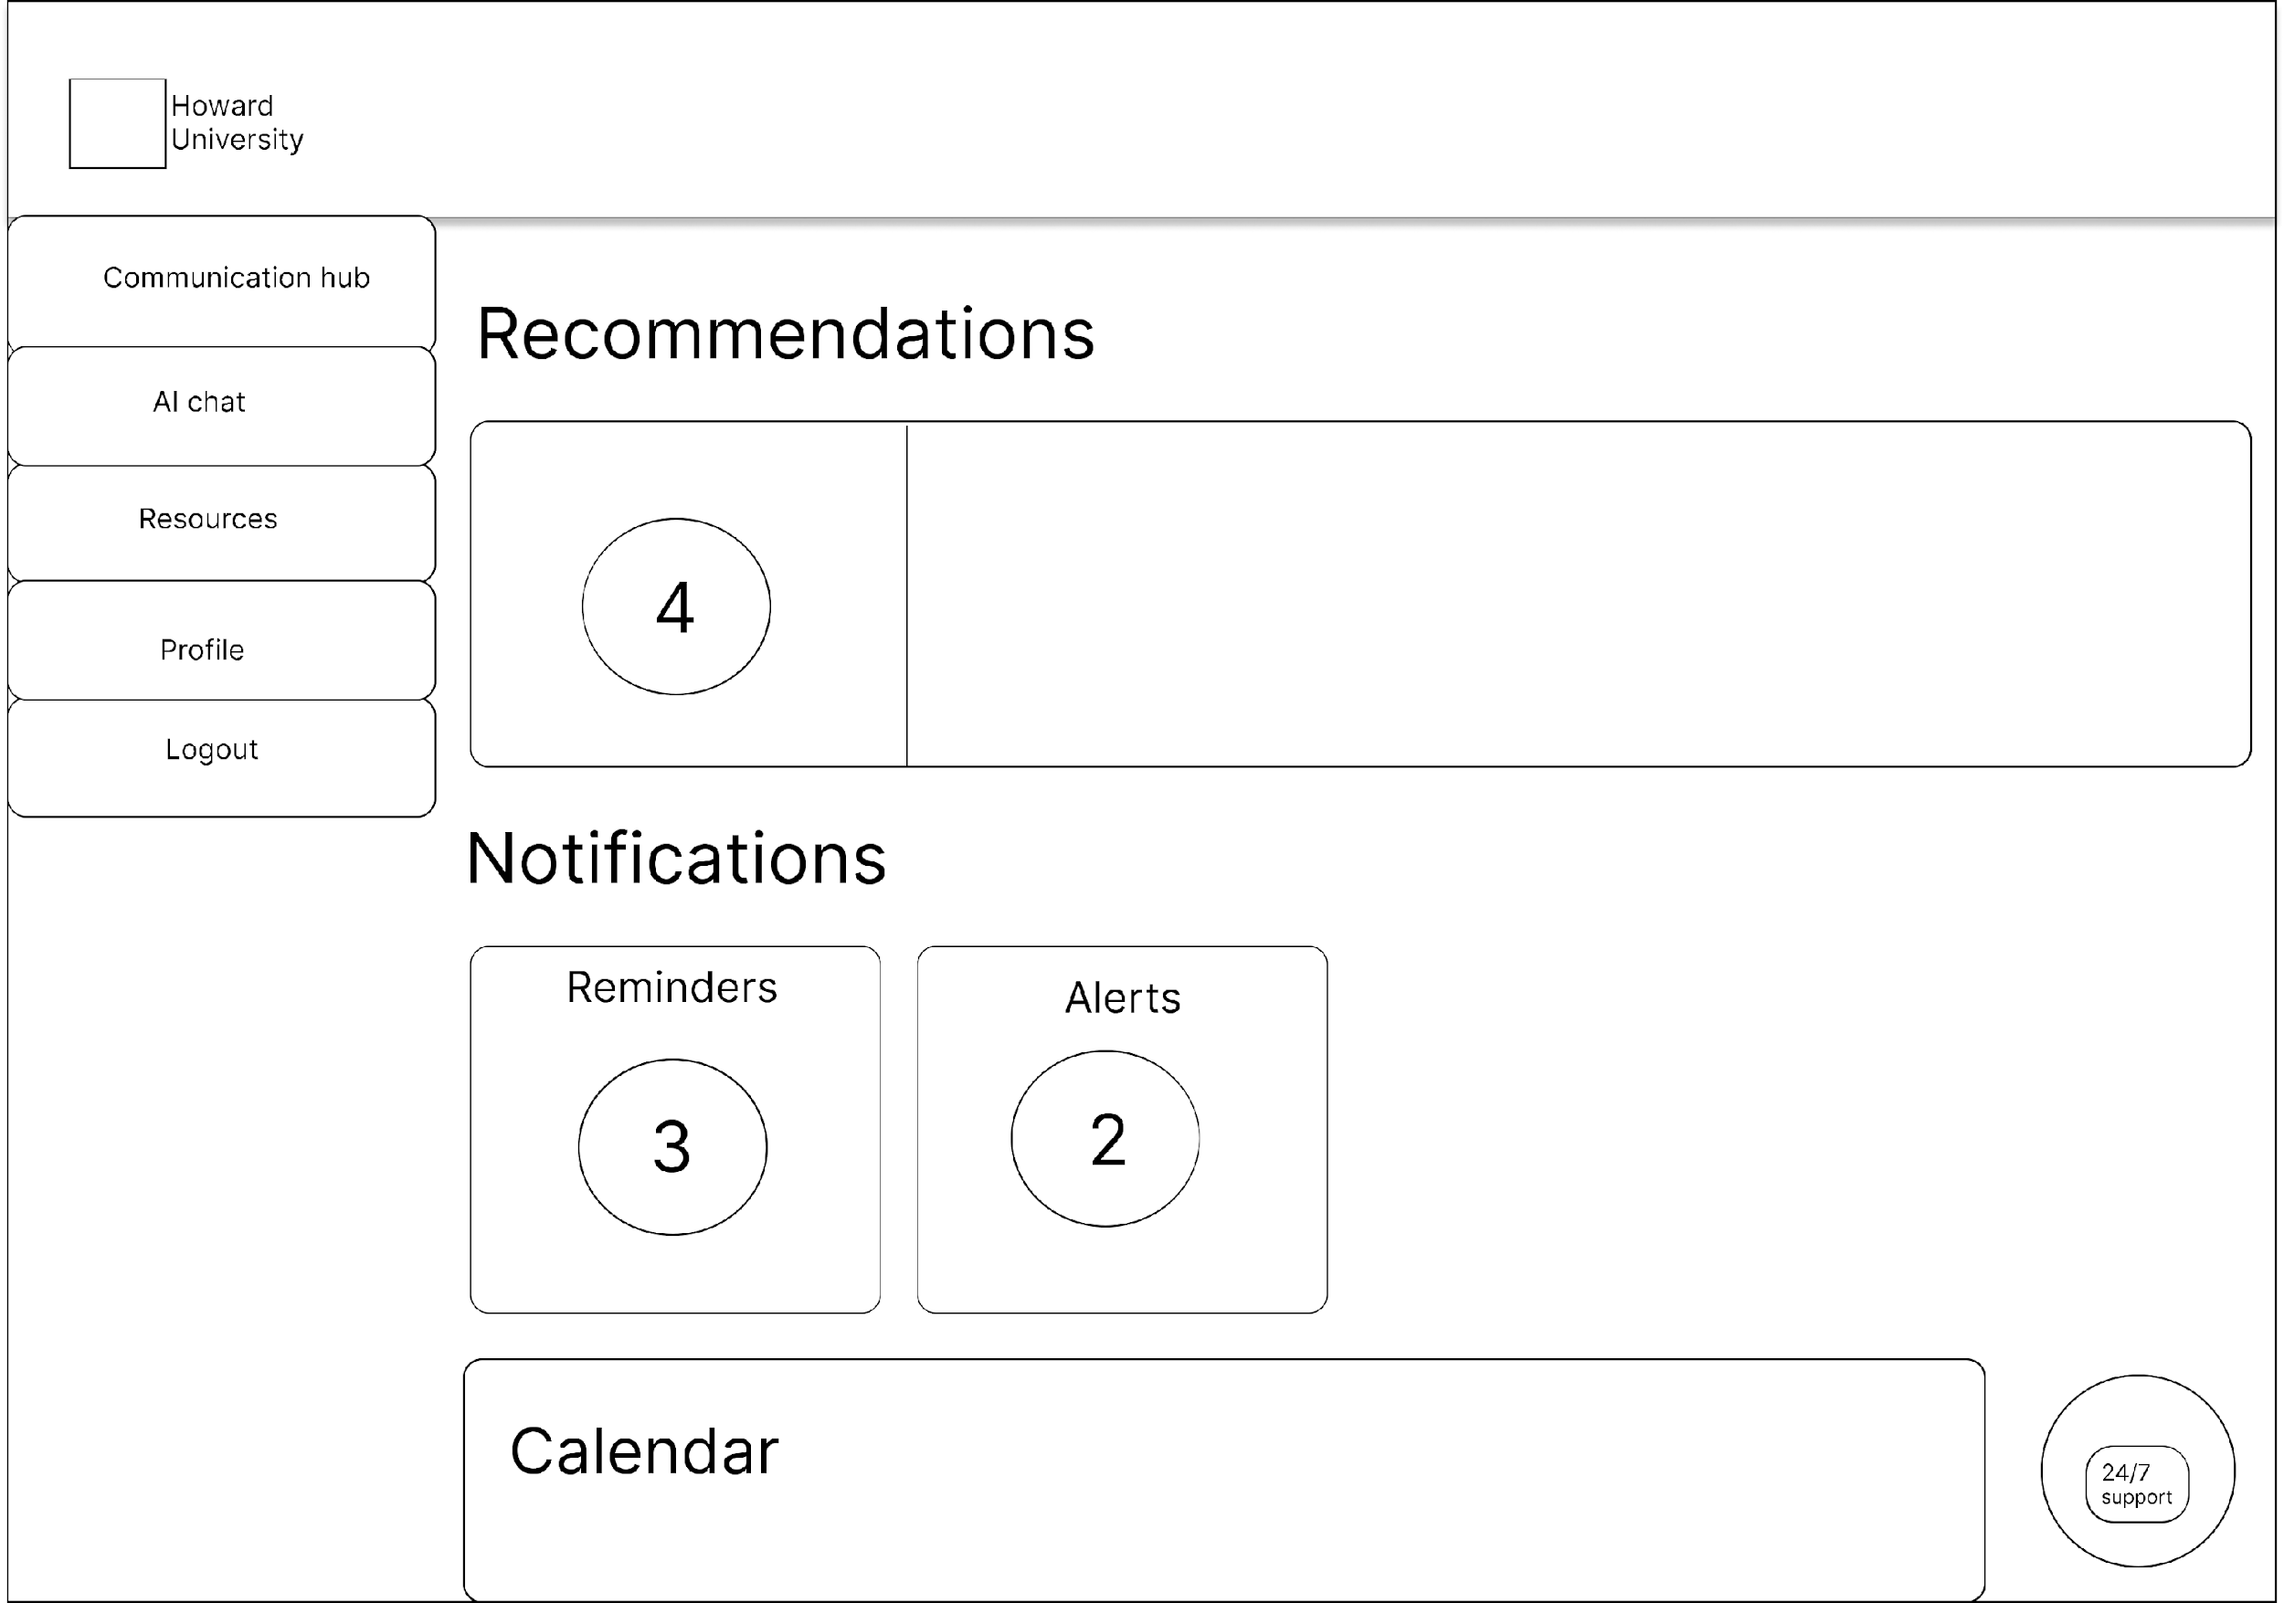

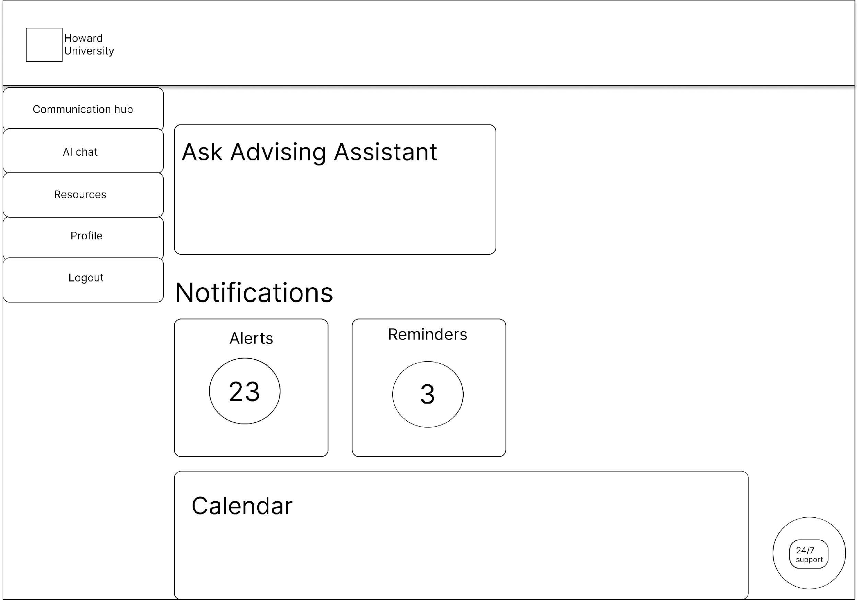

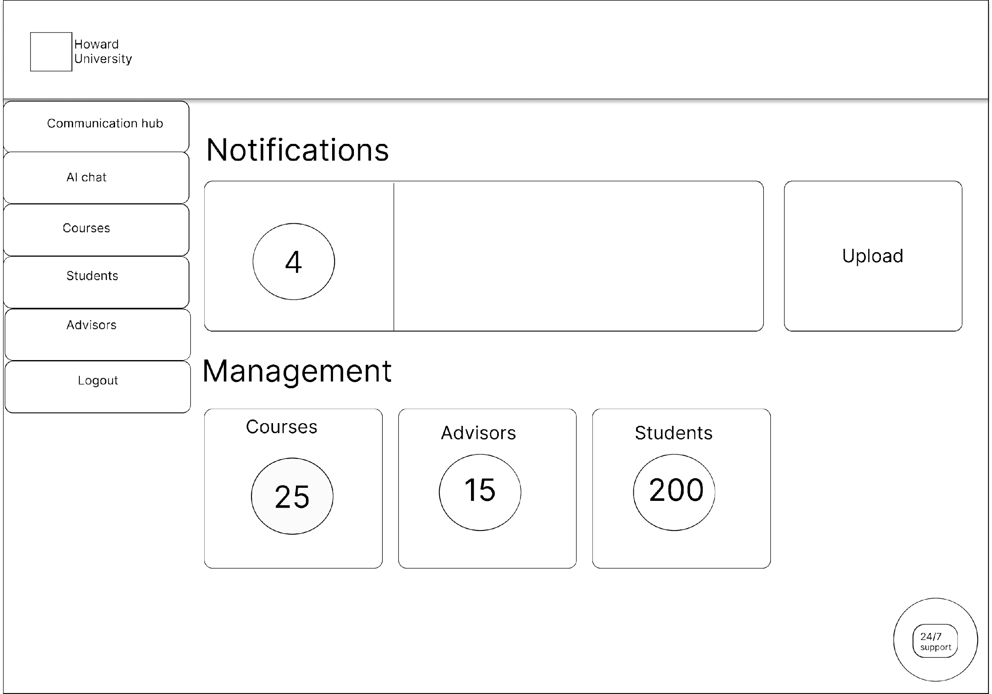

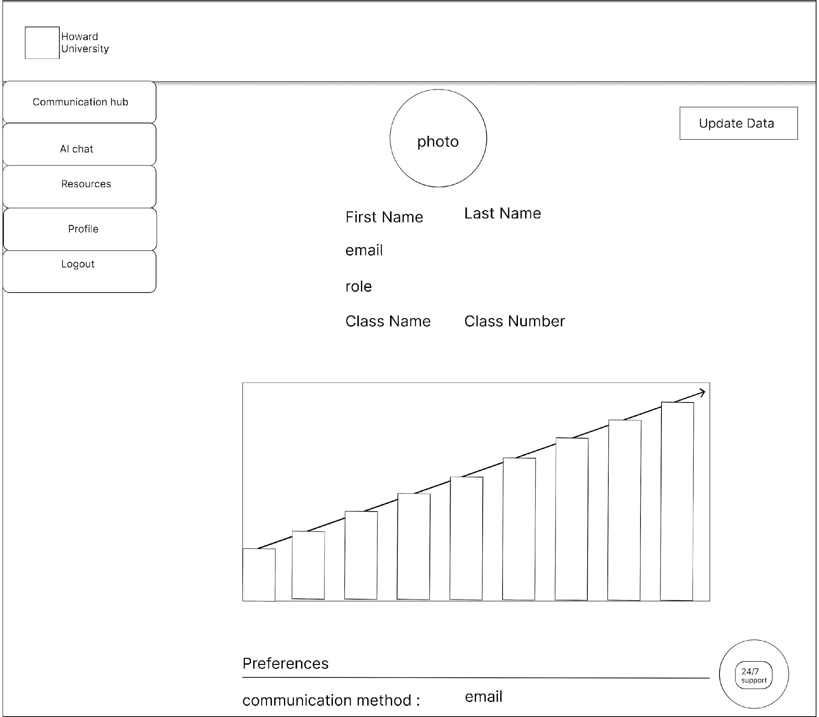

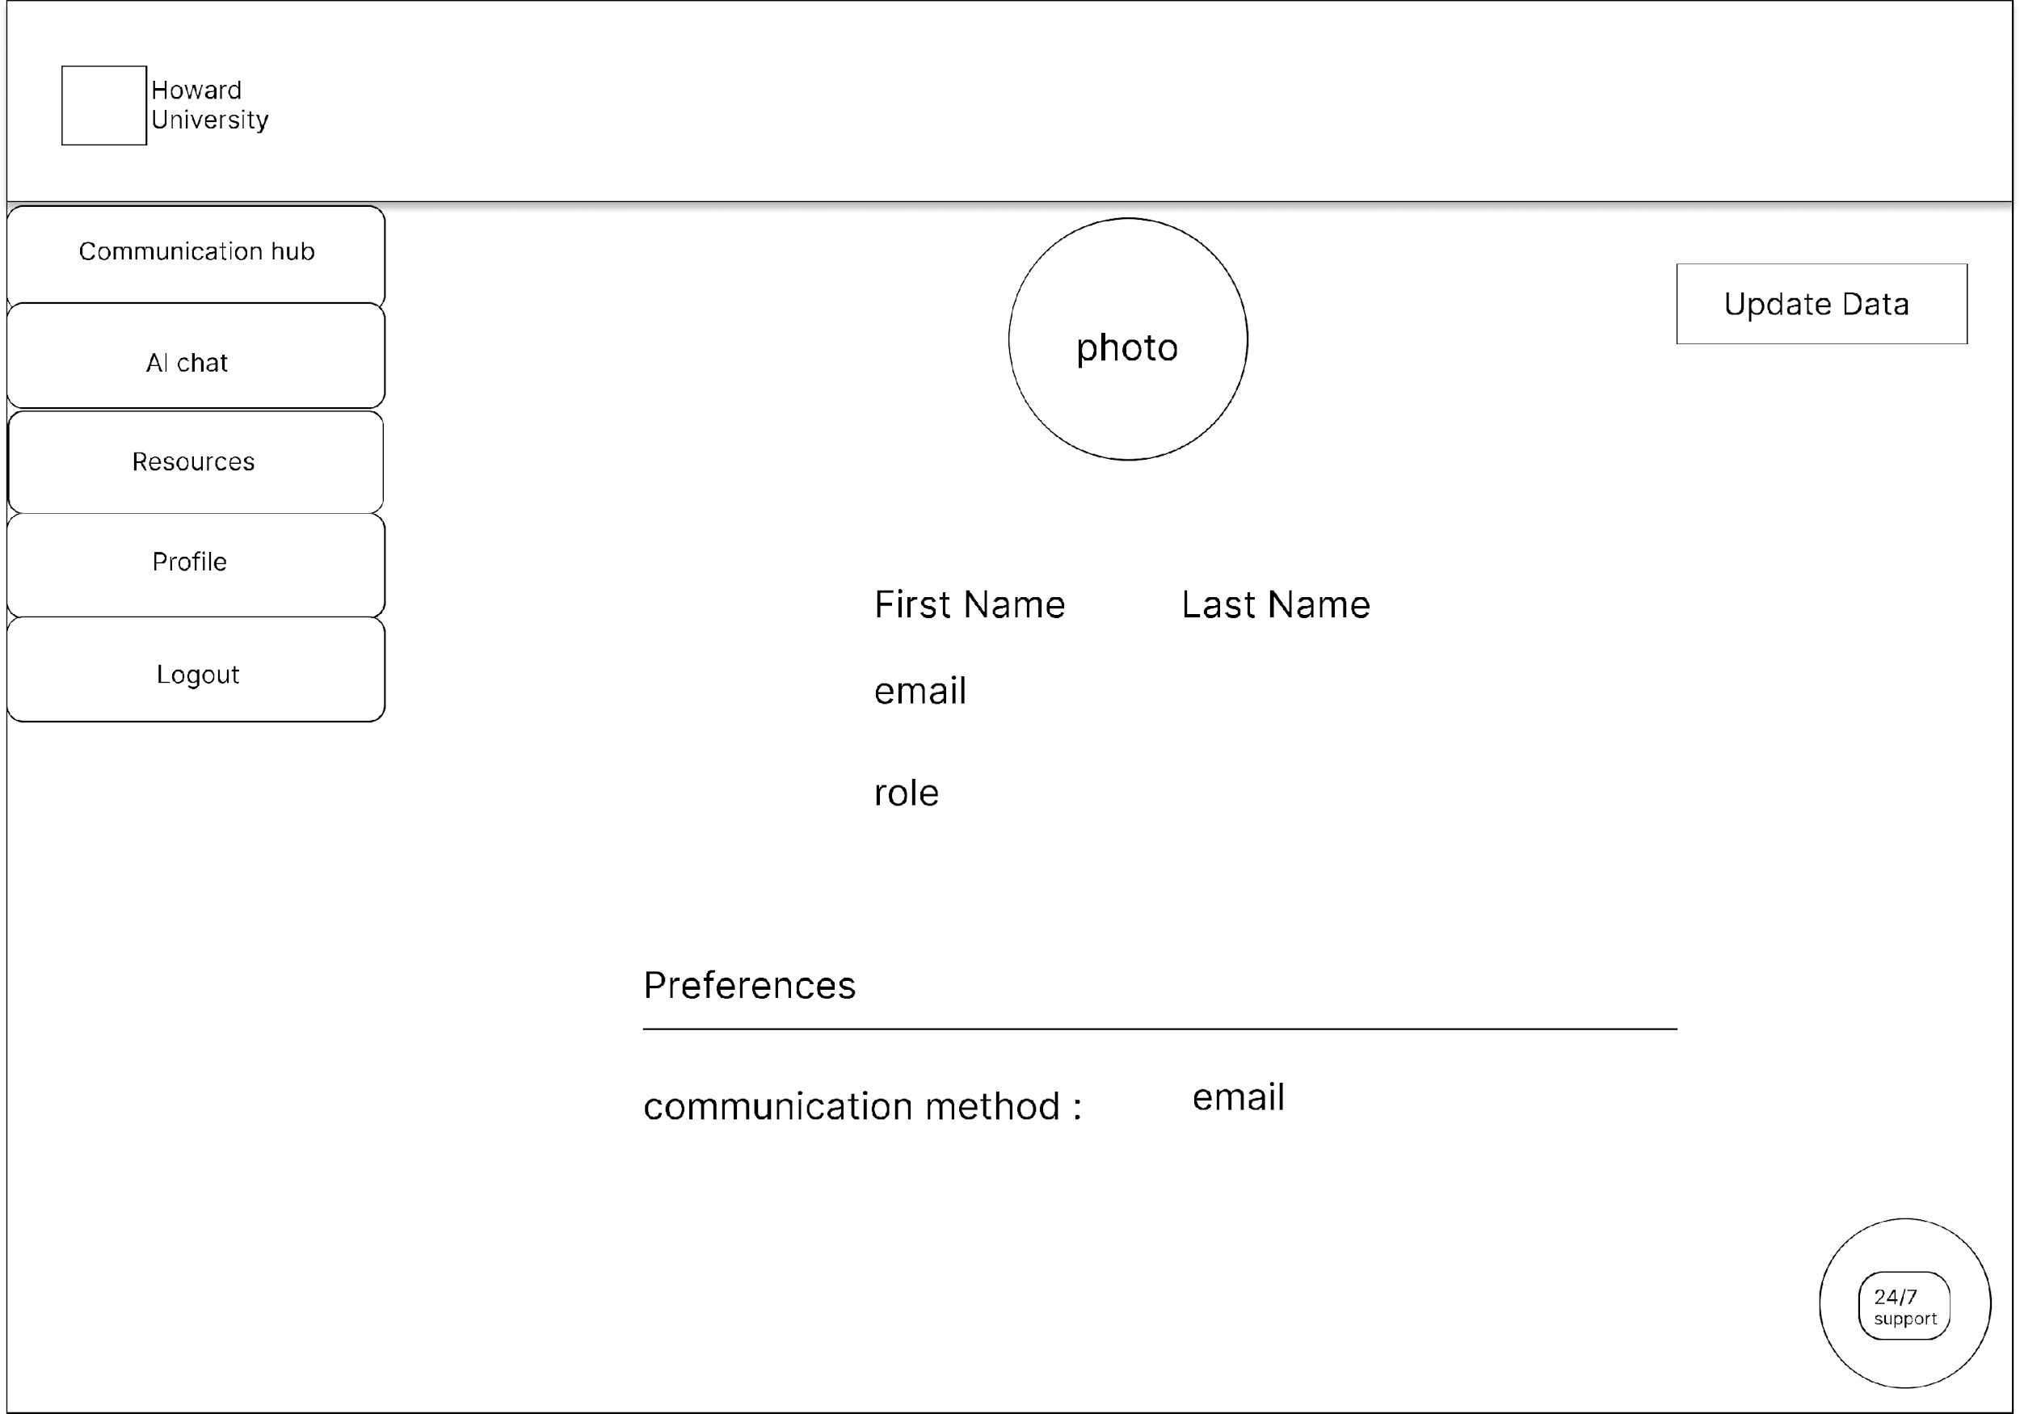

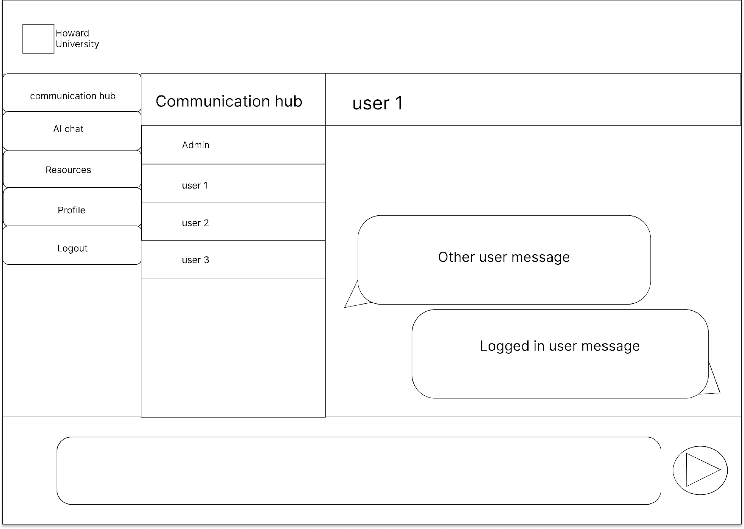

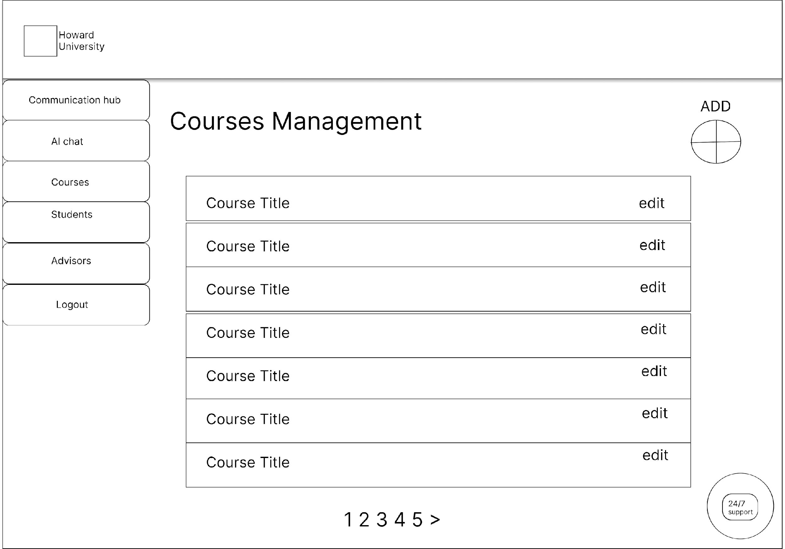

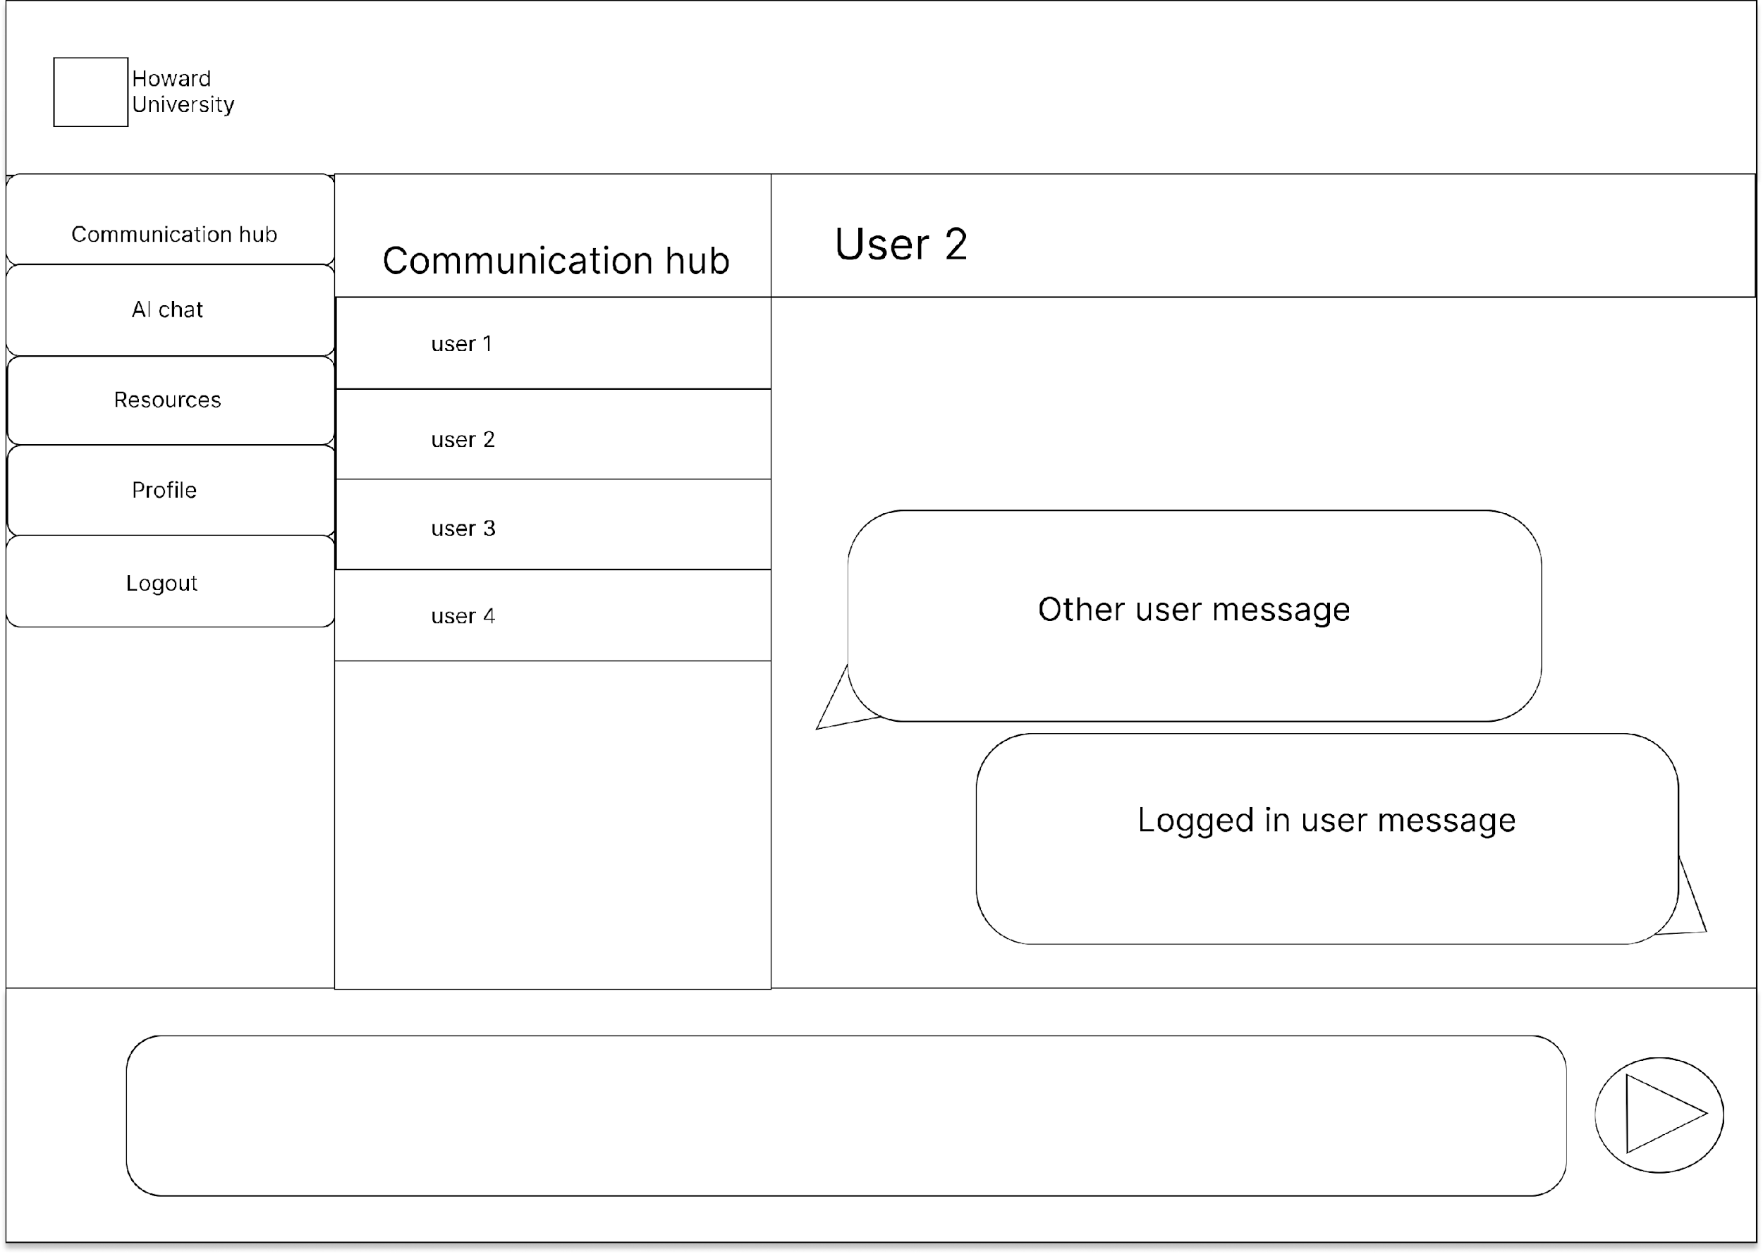

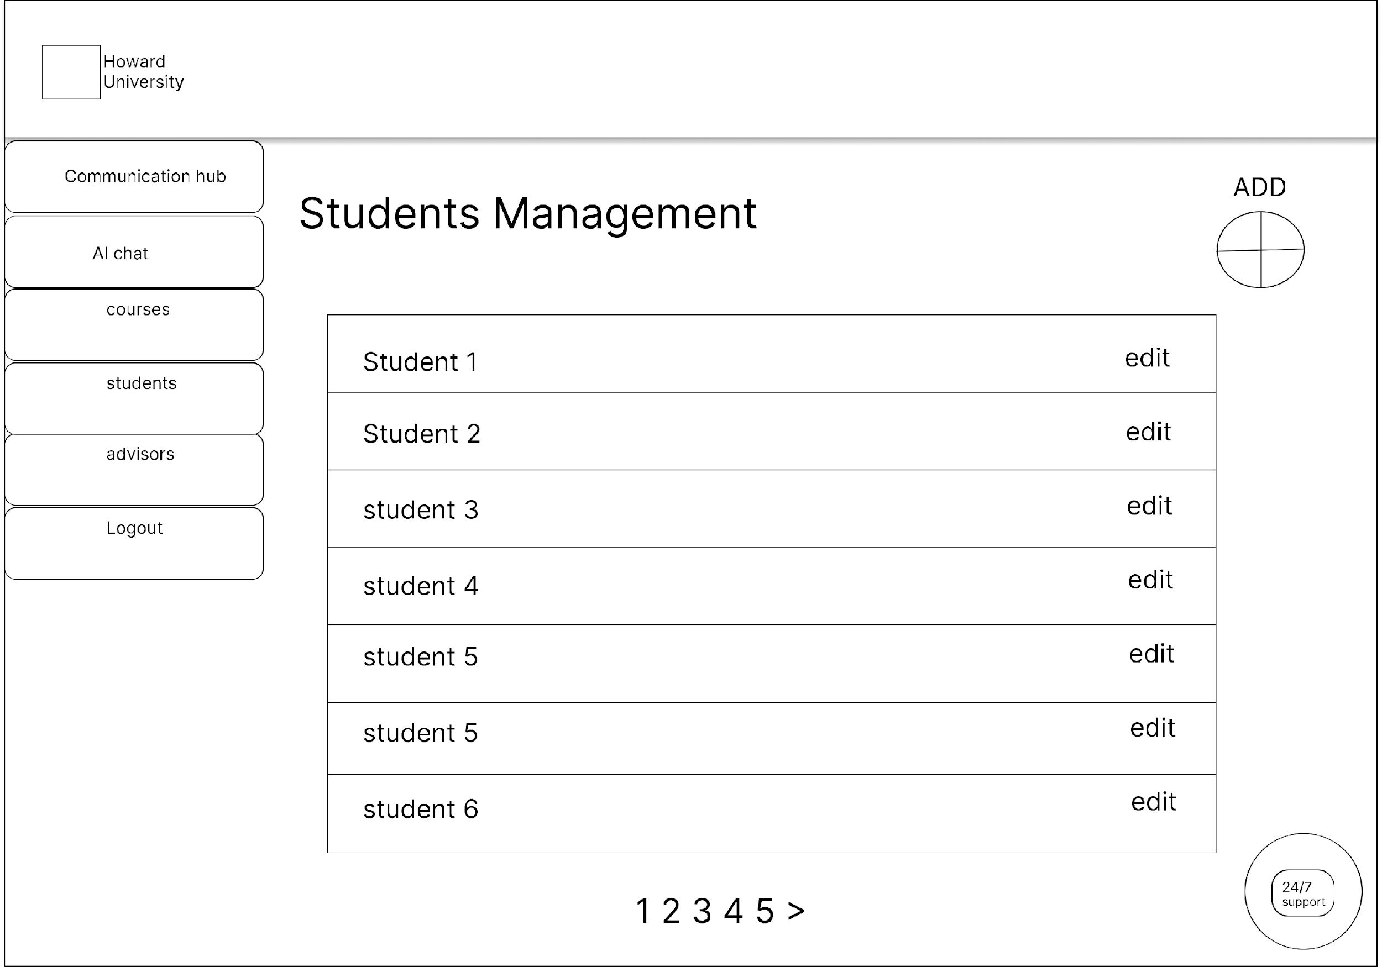

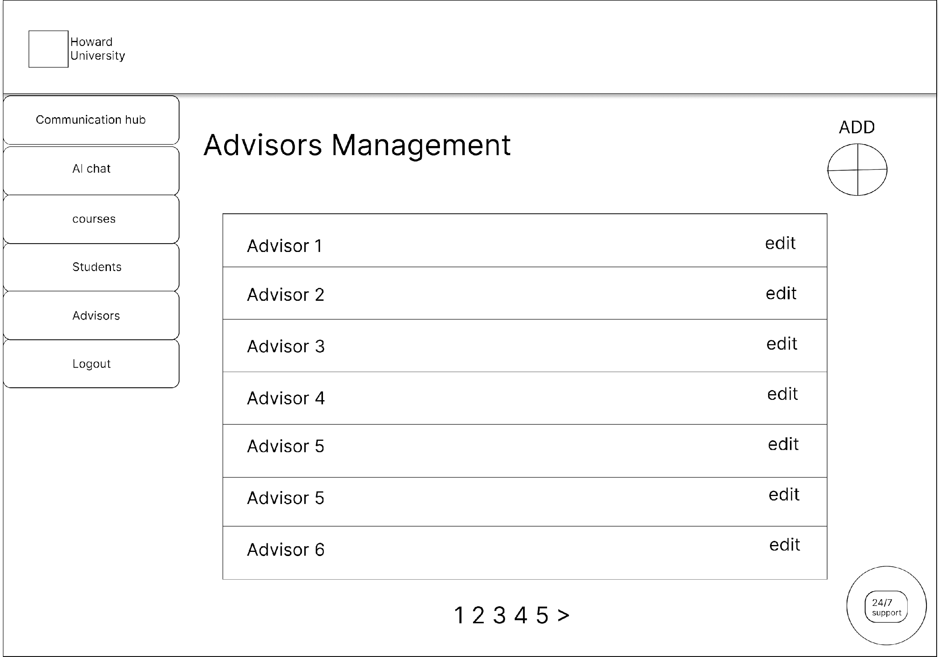

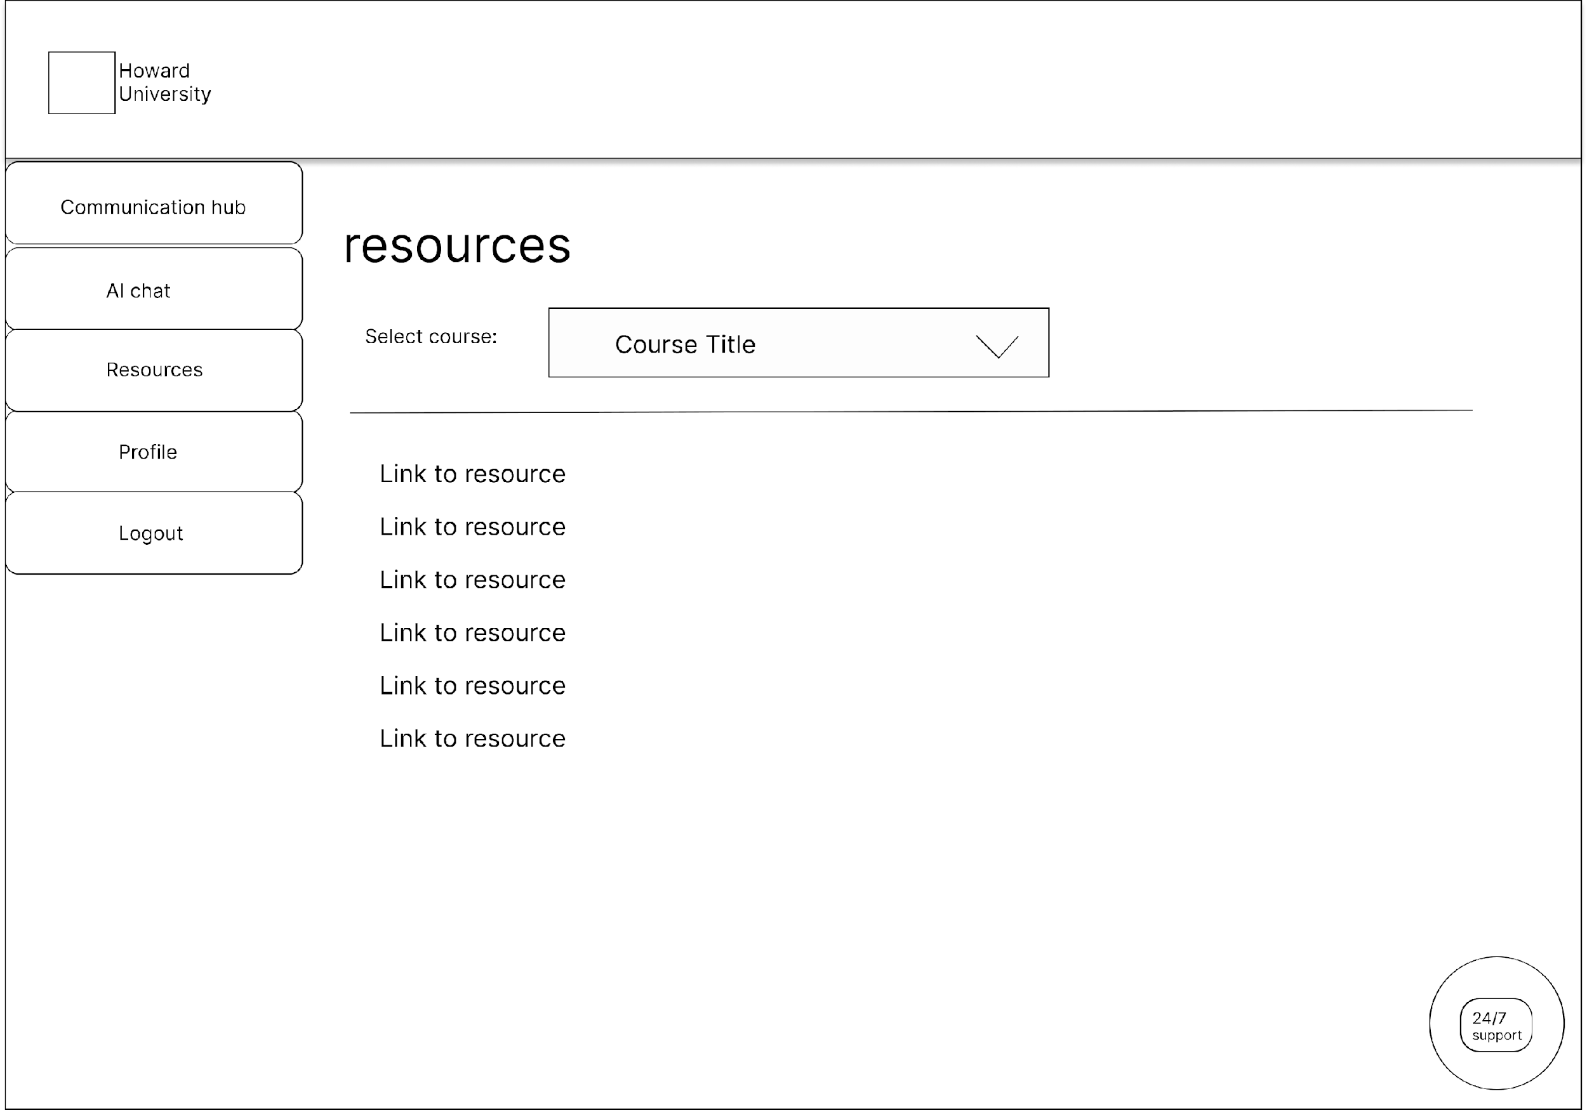

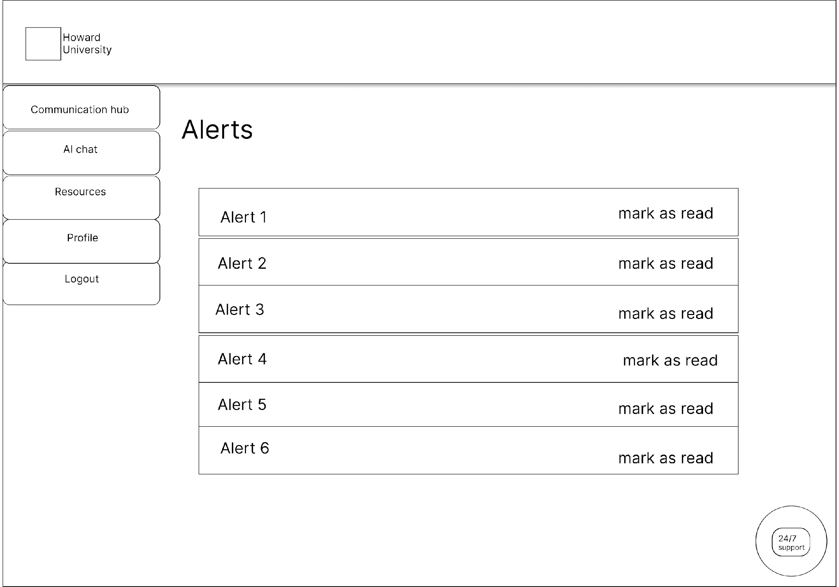

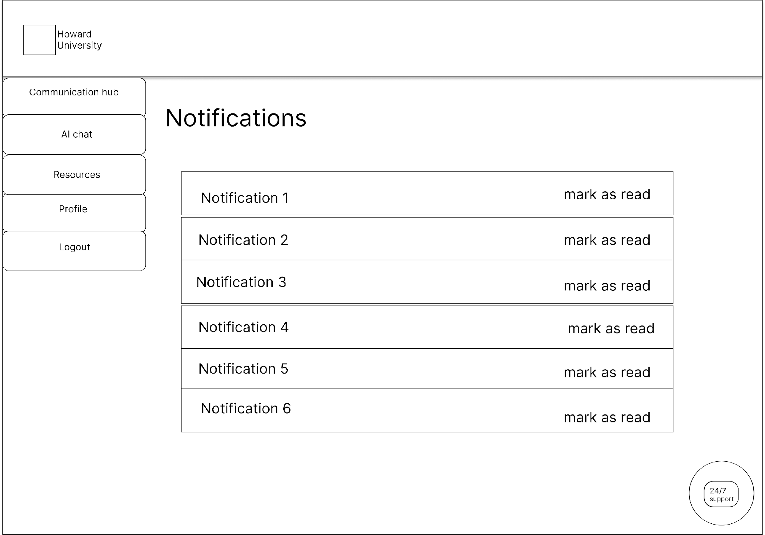

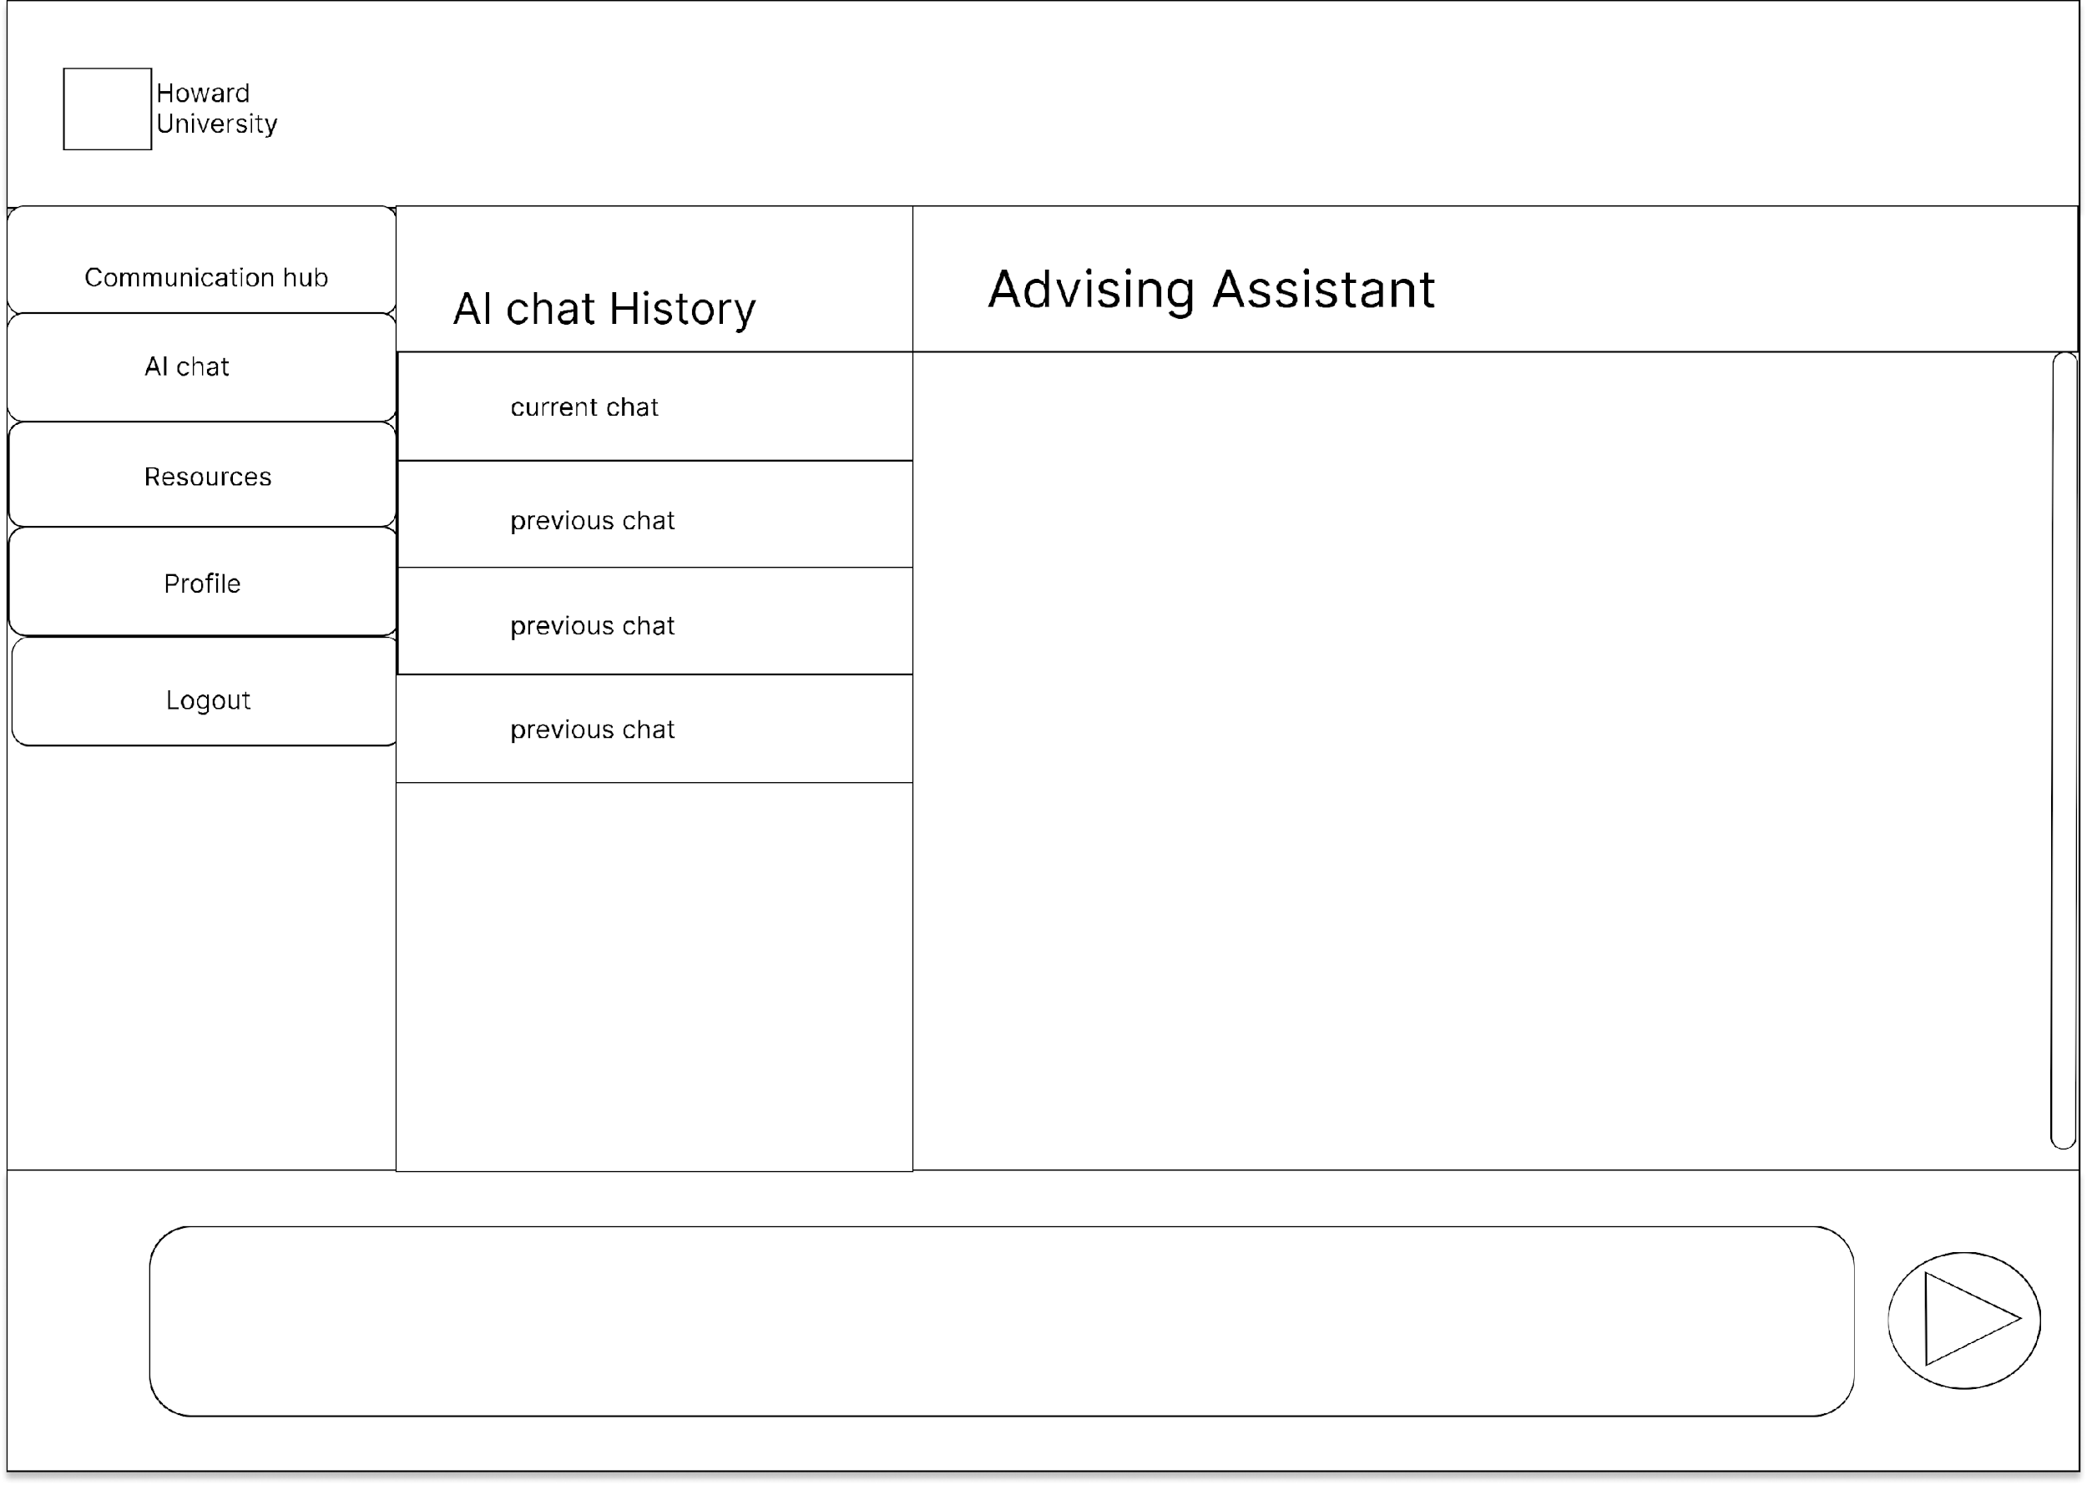

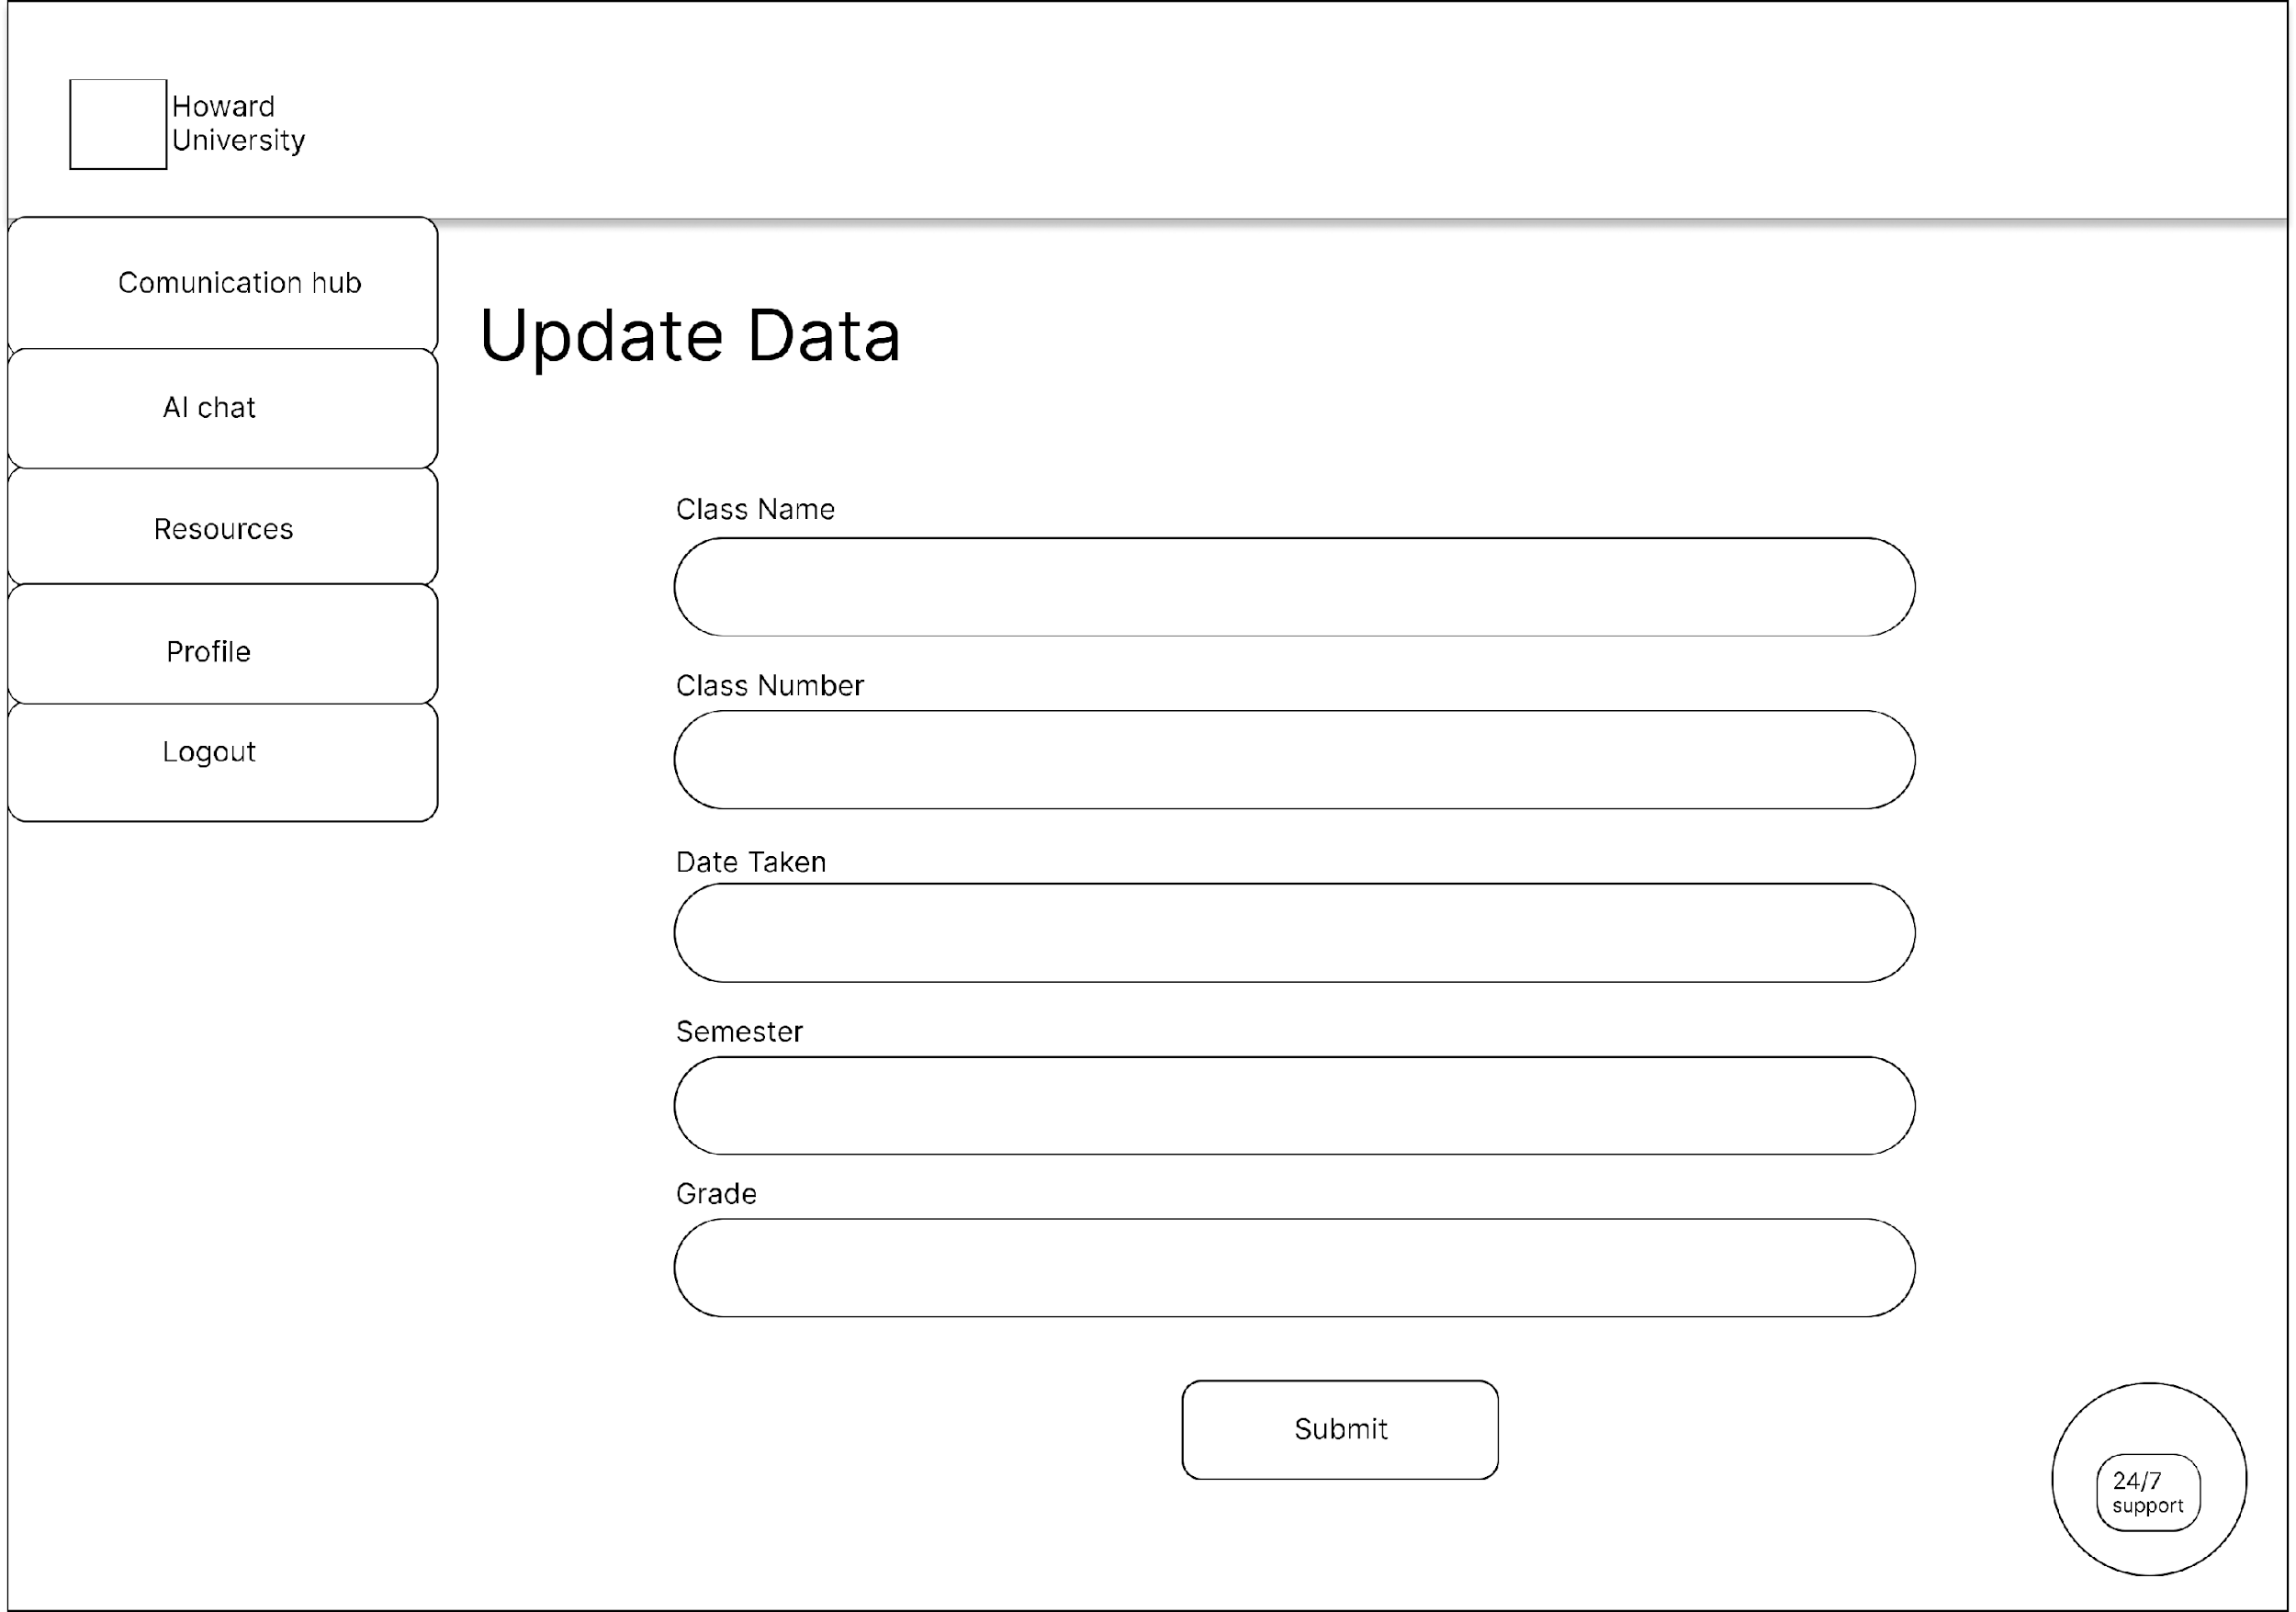

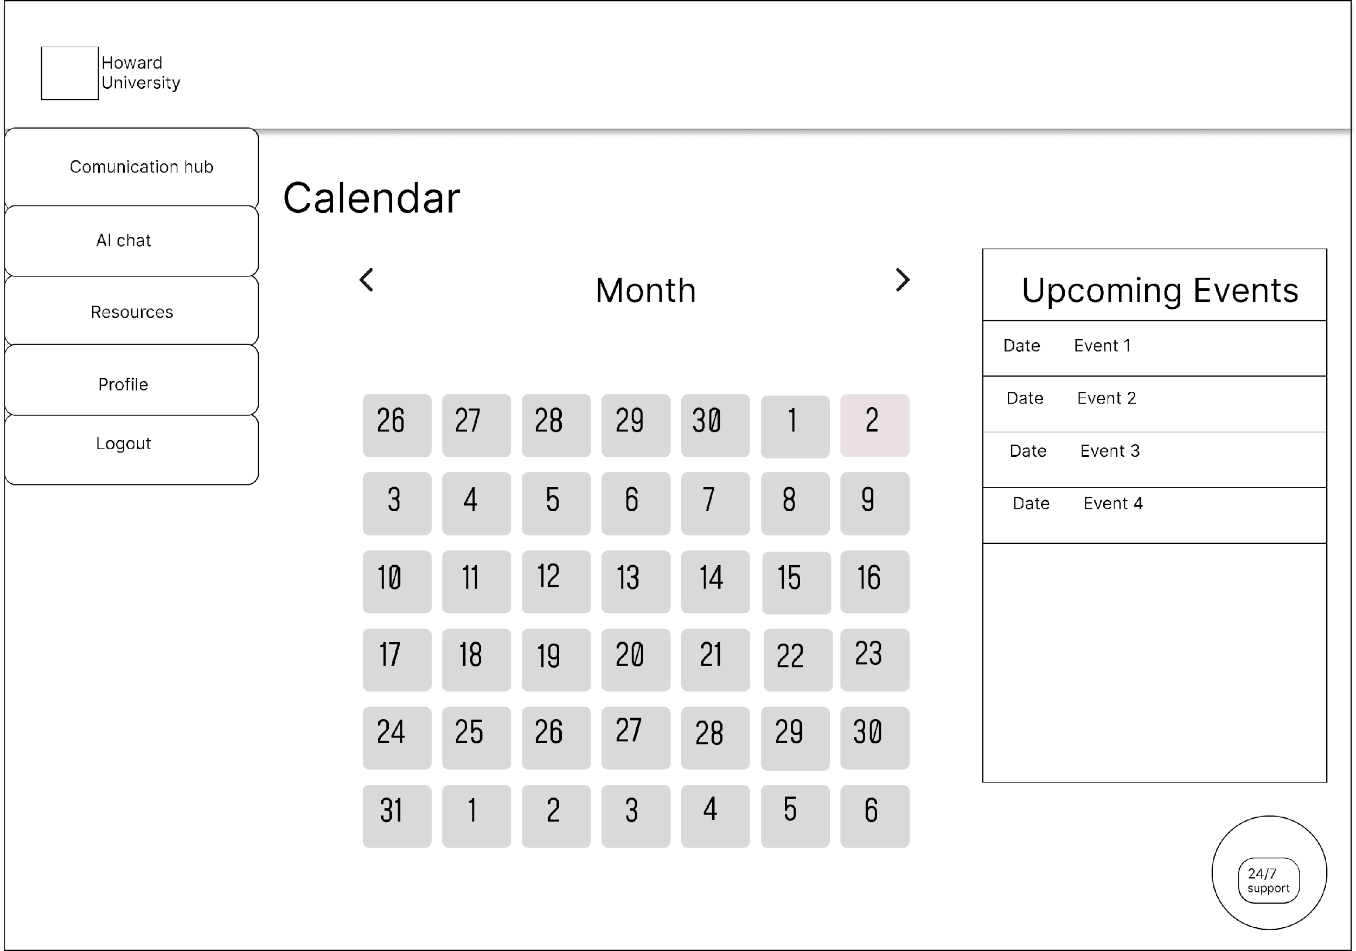

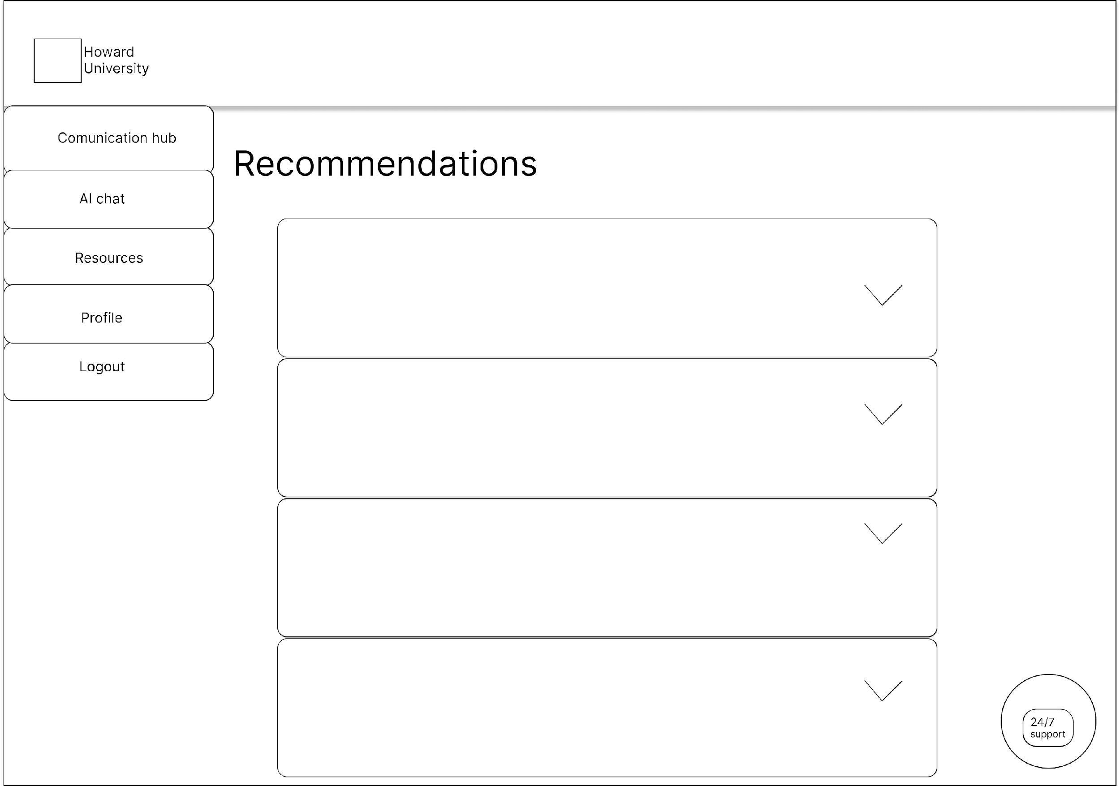

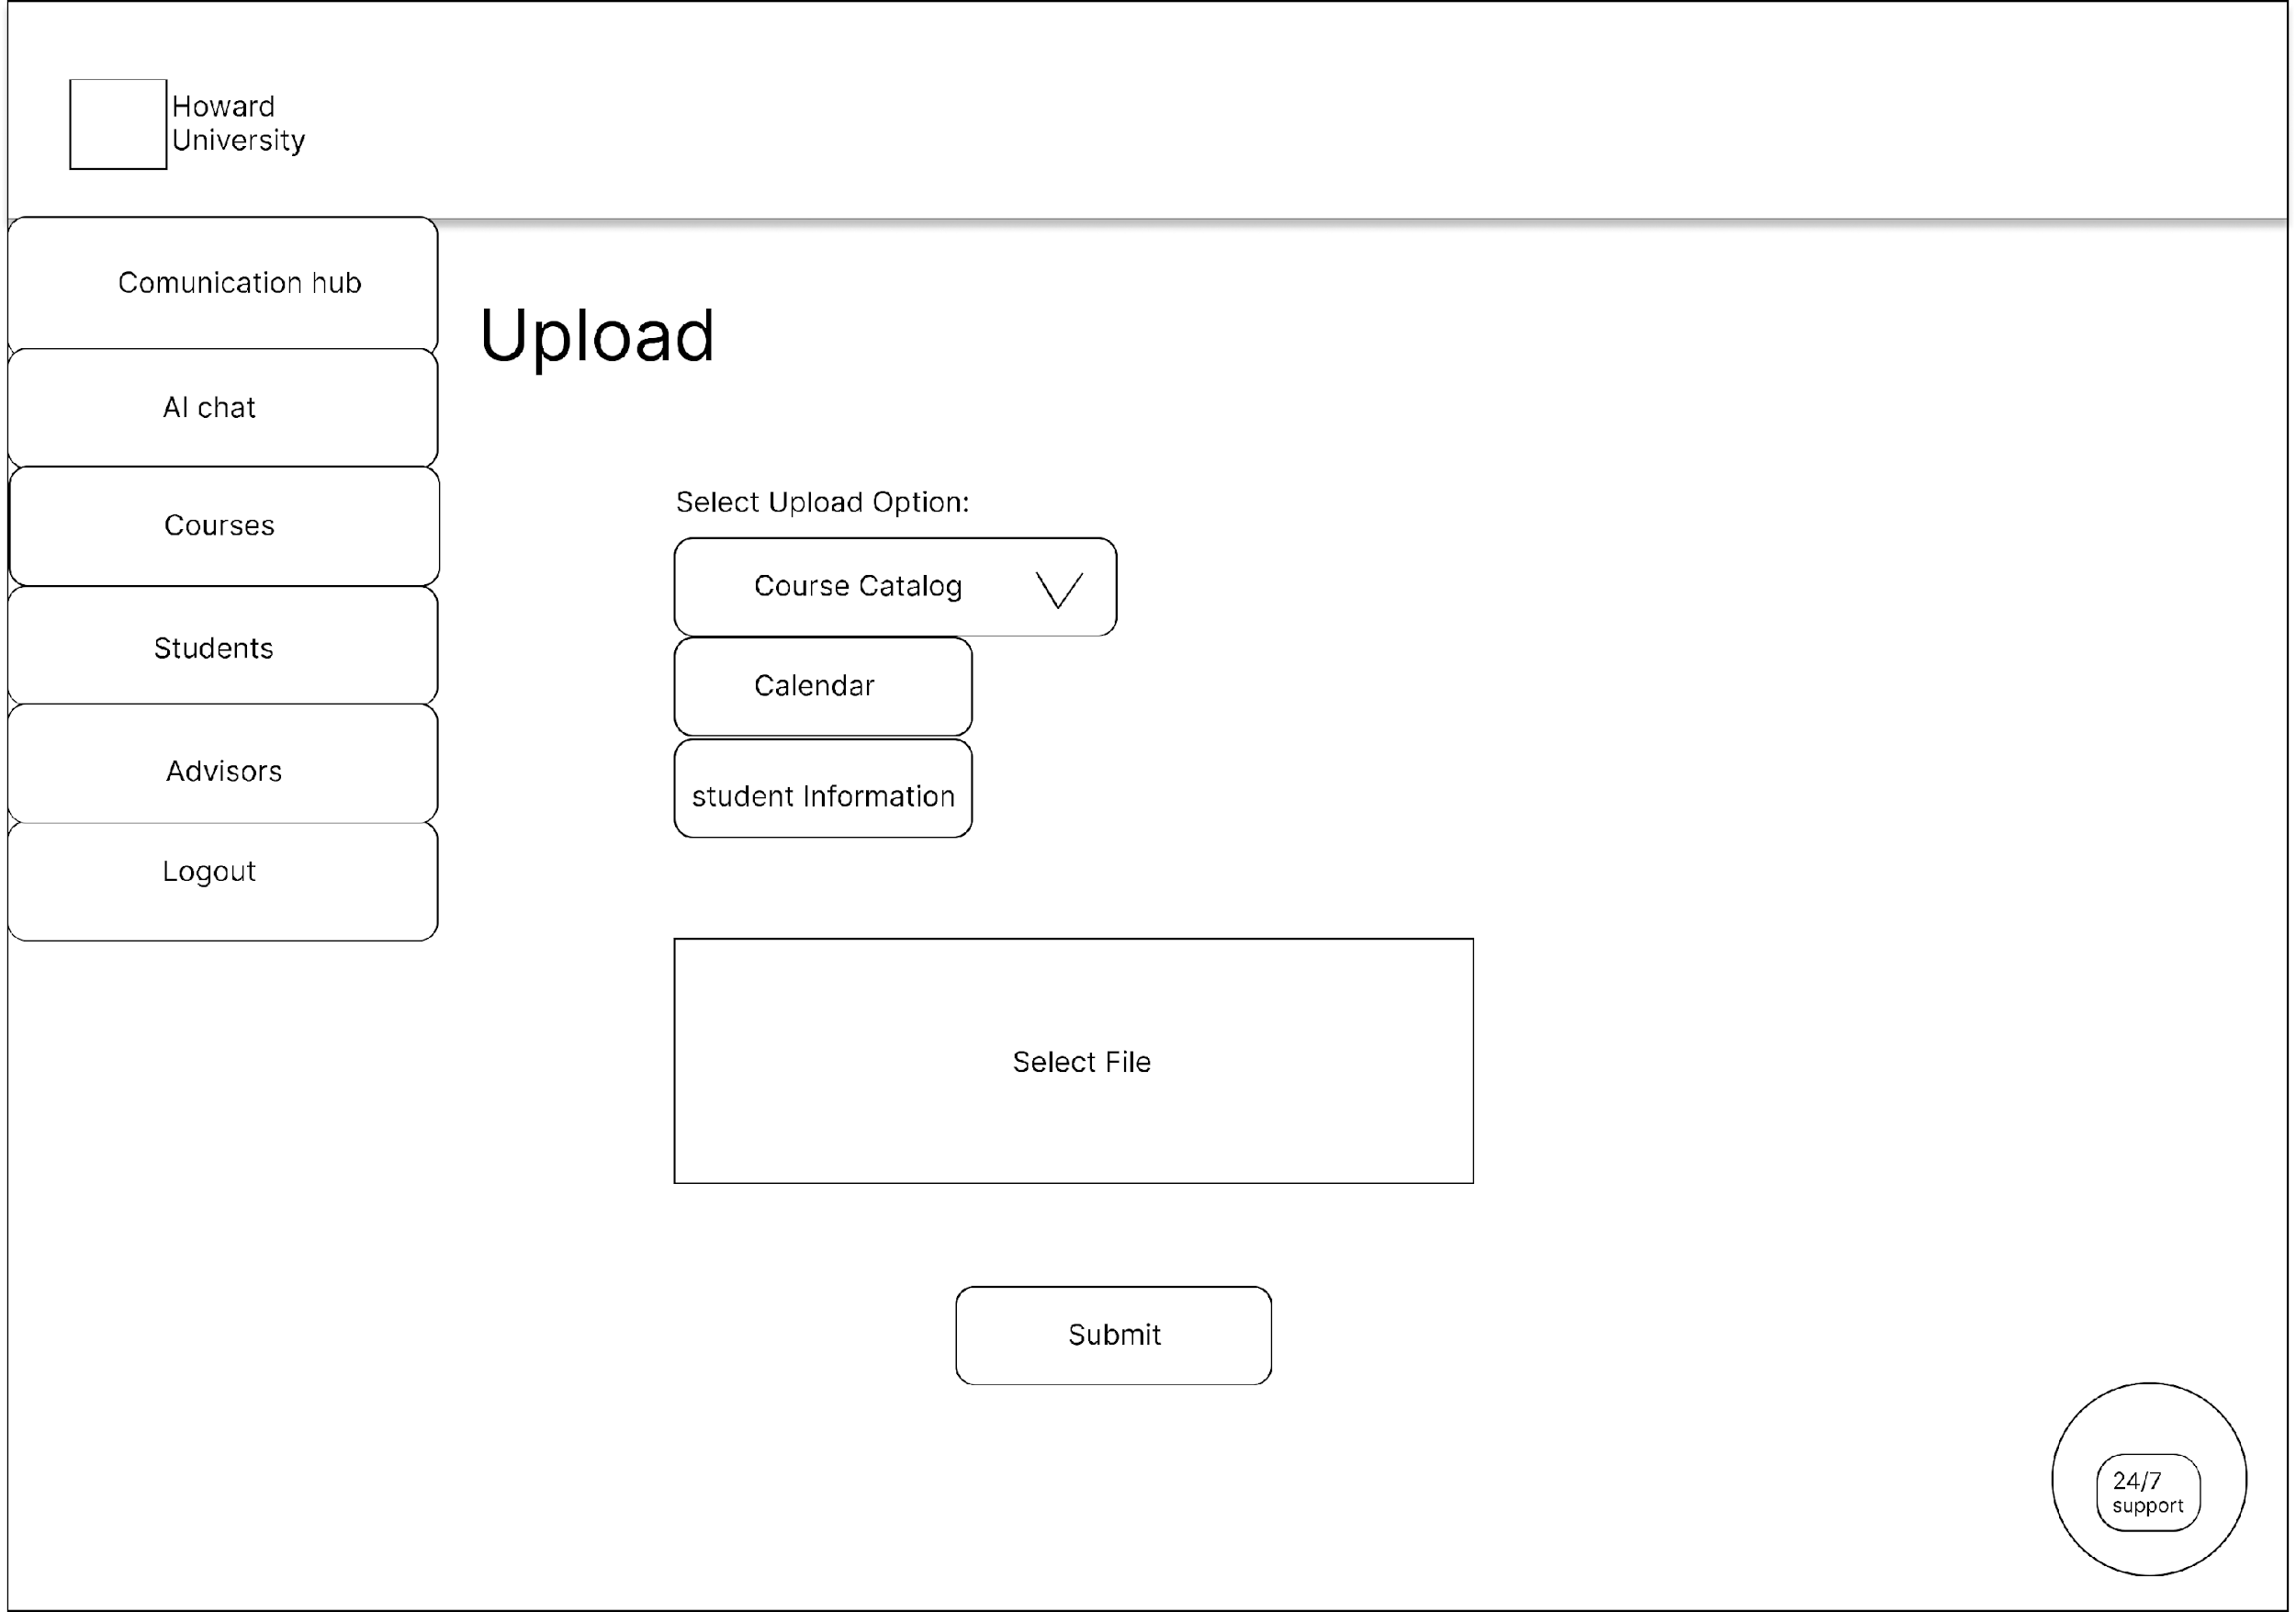

# STORYBOARDS

# Storyboards: User login and authentication

# Storyboards: User Update Profile

# Storyboards: User Chat with Generative AI model

# HEURISTIC EVALUATION

## Storyboard 1: User Login to the system

|  |  |  |
| --- | --- | --- |
| Heuristic | Valuation | Recommendation |
| Visibility of System Status | Okay |  |
| Match Between the system and real world | The notification and alerts are at the middle of the screen | Move the notifications and alerts to the top of the screen.  This will make them more prominent and conspicuous to the user |
| User Control and Freedom | Okay |  |
| Consistency and standards | The verify login input field is square shaped | Make the verify login input field have rounded edges to make it more consistent with other forms |
| Error Prevention | Okay |  |
| Recognition and not recall | Okay |  |
| Flexibility and ease of use | Okay |  |
| Aesthetic and minimalist design | Okay |  |
| Help Users recognize, diagnose, and recover from errors | Okay |  |
| Help and documentation | Not there | The design is minimal and easy to understand for users in all experience gaps.  However, adding a few tips on the dashboard will help users acclimate faster to the system |

## Heuristic 2: Updating Student Data

|  |  |  |
| --- | --- | --- |
| Heuristic | Valuation | Recommendation |
| Visibility of System Status | Okay |  |
| Match Between the system and real world | Okay |  |
| User Control and Freedom | Missing back navigation buttons | Include a back button to take the user back to previous screens |
| Consistency and standards | Okay |  |
| Error Prevention | Okay |  |
| Recognition and not recall | Okay |  |
| Flexibility and ease of use | Okay |  |
| Aesthetic and minimalist design | Okay |  |
| Help Users recognize, diagnose, and recover from errors | Okay |  |
| Help and documentation | Not there | The design is minimal and easy to understand for users in all experience gaps.  However, adding a few tips on the dashboard will help users acclimate faster to the system |

## Heuristic 3:

|  |  |  |
| --- | --- | --- |
| Heuristic | Valuation | Recommendation |
| Visibility of System Status | Okay | Add information about the current user in the dashboard and chat screen |
| Match Between the system and real world | Okay |  |
| User Control and Freedom | Okay |  |
| Consistency and standards | Navigation drawers are not full height | Make the navigation drawers fill the screen vertically |
| Error Prevention | Okay |  |
| Recognition and not recall | Okay |  |
| Flexibility and ease of use | Okay |  |
| Aesthetic and minimalist design | Okay |  |
| Help Users recognize, diagnose, and recover from errors | Okay |  |
| Help and documentation | Not there | The design is minimal and easy to understand for users in all experience gaps.  However, adding a few tips on the dashboard will help users acclimate faster to the system |

# SITEMAP

